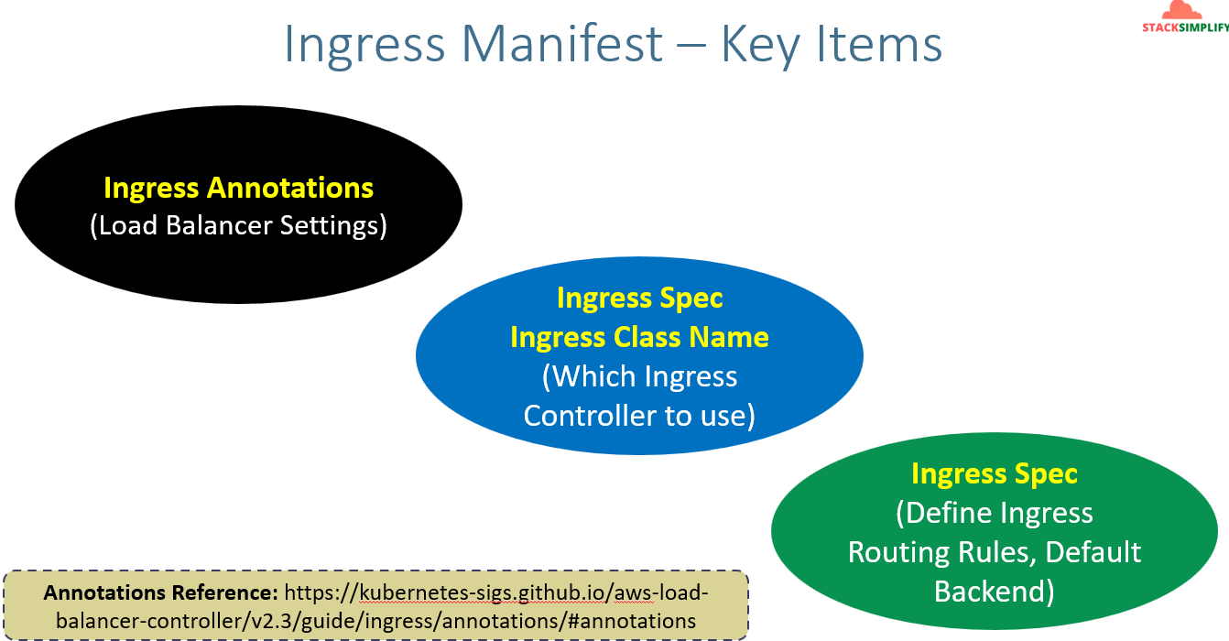
Annotations Ref: https://kubernetes-sigs.github.io/aws-load-balancer-controller/v2.3/guide/ingress/annotations/#annotations
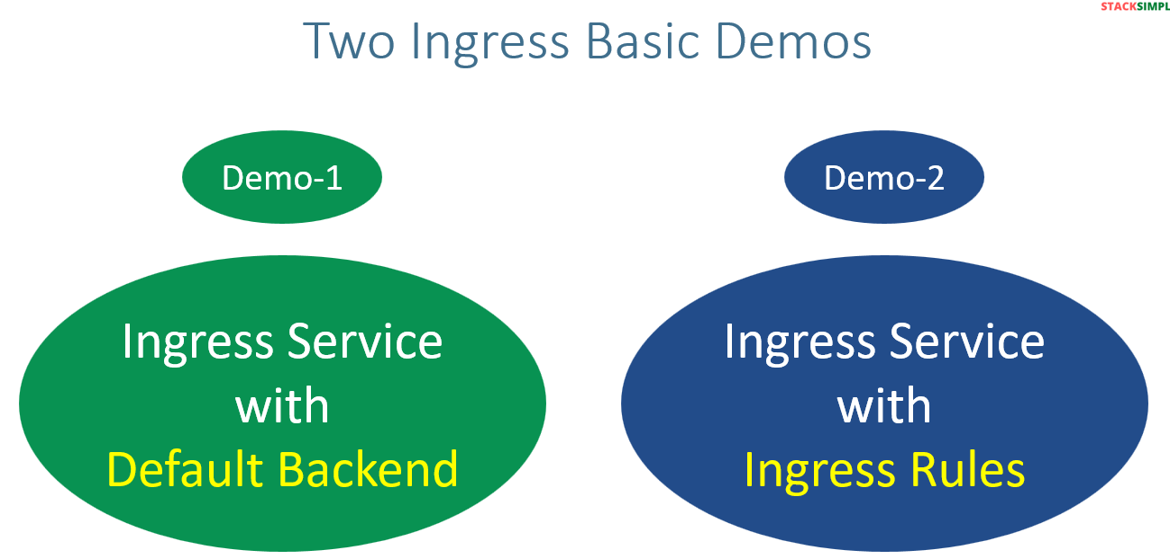
Network design for Default backend:-
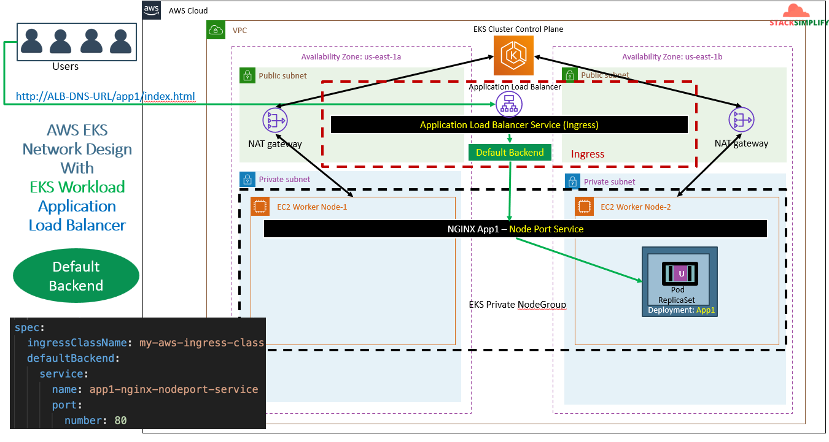
Network design for Ingress Rules:-
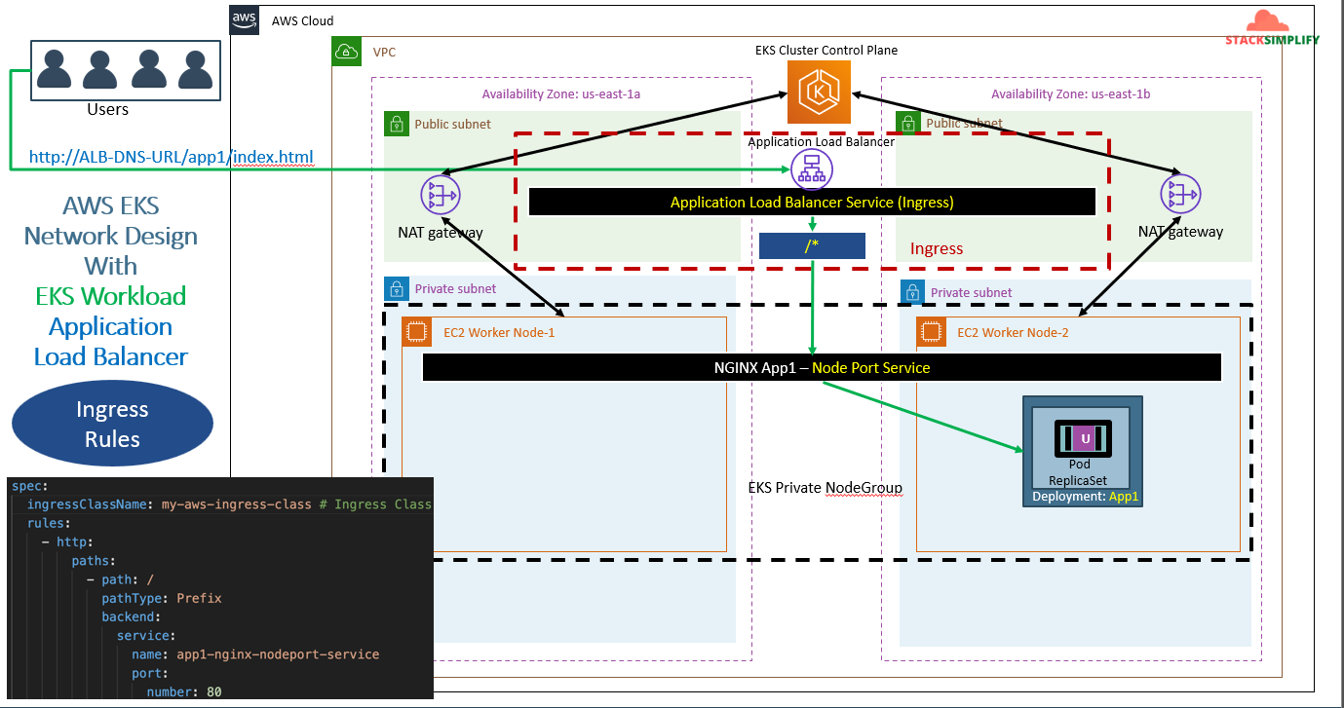
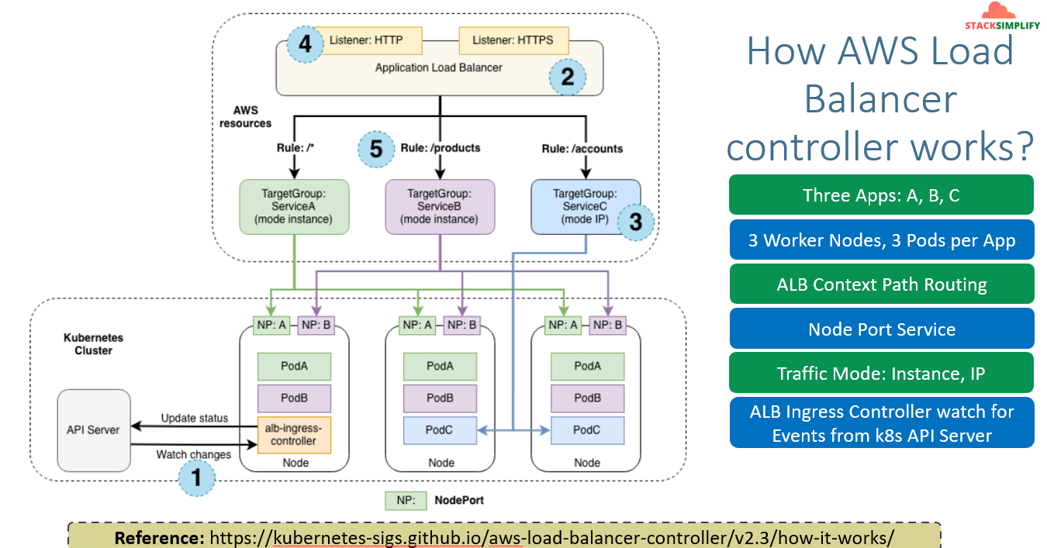
If you see ServiceA and B’s mode is instance means node groups are registered in target group of LB through NodePort service the traffic will be routed to Service1 & 2 but the service C is having traffic mode IP that means PODs IP are directly registered to TG. Mainly we can use Traffic mode : IP while using Fargate.
Create Ingress K8s manifest with default backend:-
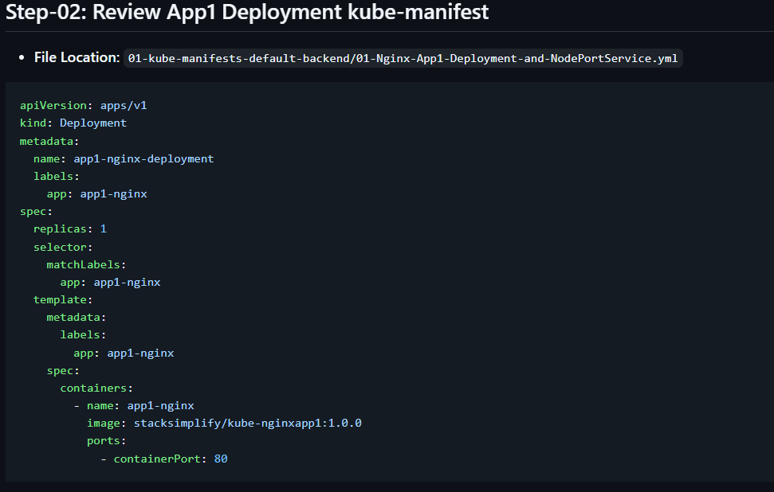
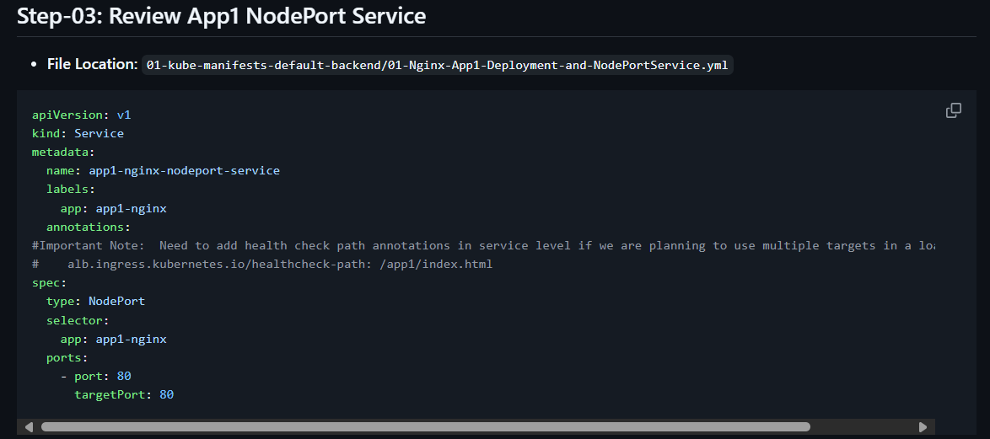
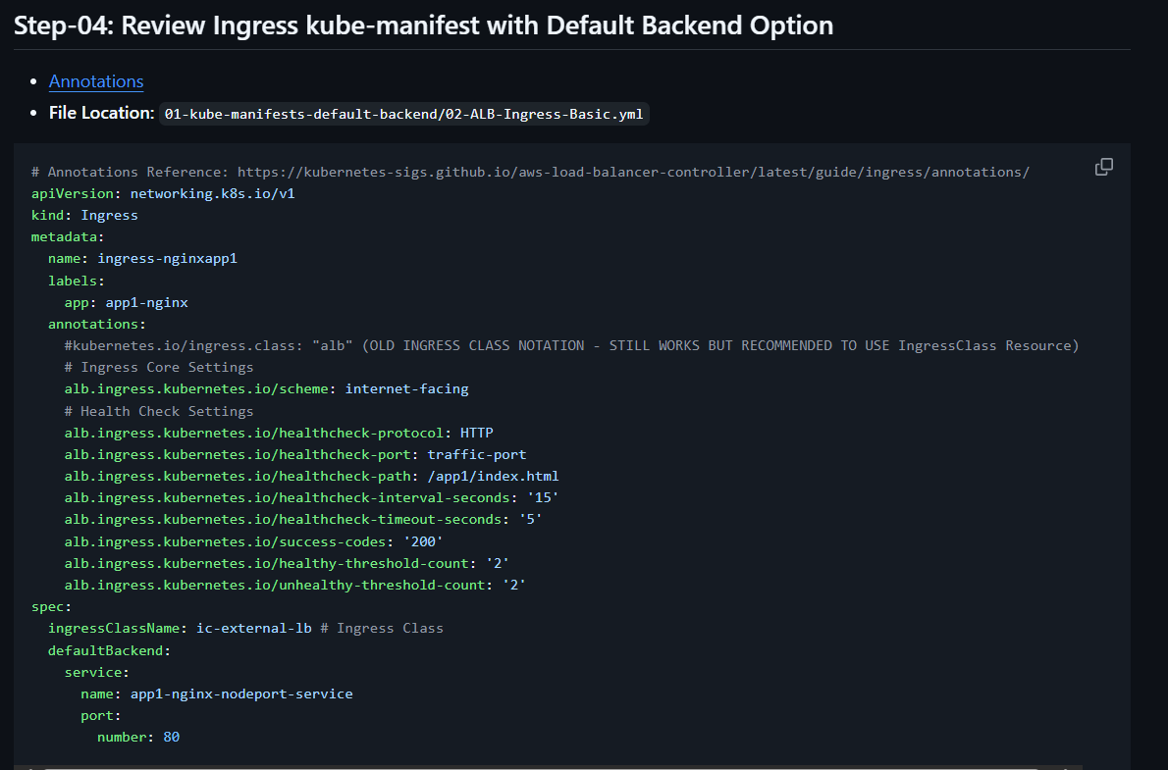
Since we are having single context path ‘alb.ingress.kubernetes.io/healthcheck-path: /app1/index.html ‘ we are defining the annotation as global in Ingress.
If we have multiple we will define in service manifest. You can see the Note point in SS of deployment.
After running kubectl apply run ‘kubectl get deploy’ and check for pods whether they are up or not. Once they are up run ‘kubectl get ingress’.
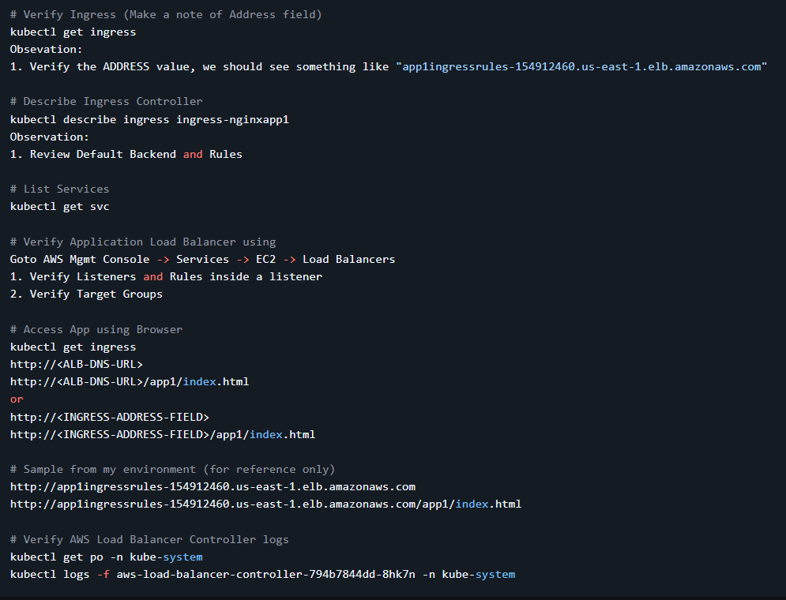
Once above steps are verified delete the objects
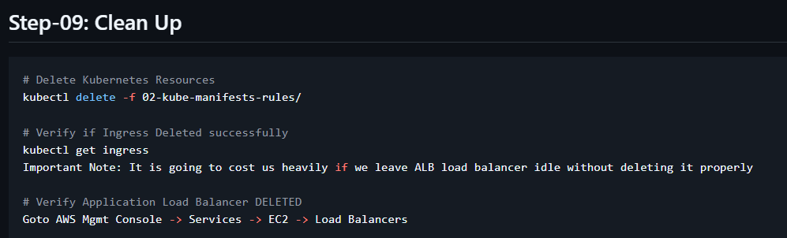
Ingress rules:-
Ingress path type explanation/overview in this doc Ingress | Kubernetes . Here in this doc we have 2 types exact and prefix. Prefix is loosely coupled and exact is exactly we need to mention.
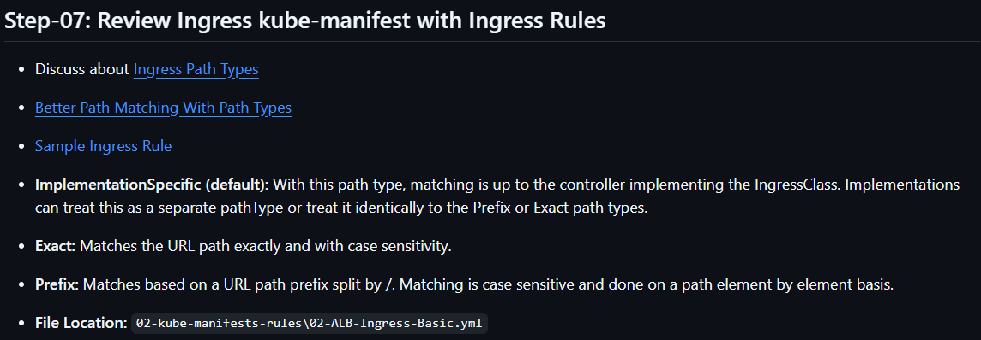
Update the script for ingress.
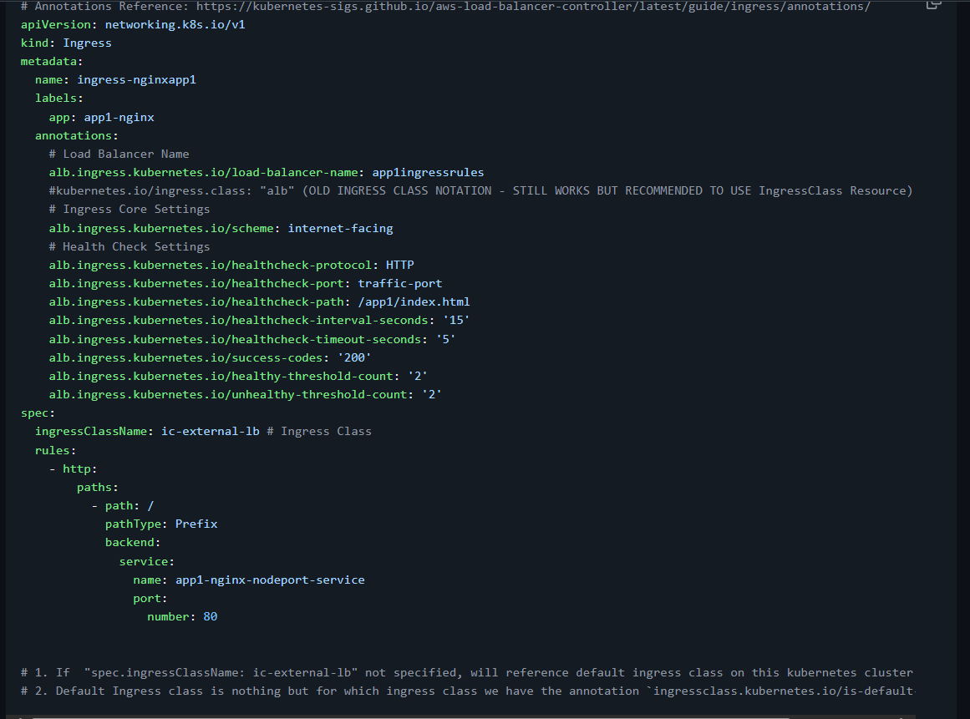
After excuting kubectl apply command
Verify the ingress. You can see that Default backend it’s nothing there since we are using ingress rules.
If you want to play around at ‘path’ add ‘/app1’ and try in browser.
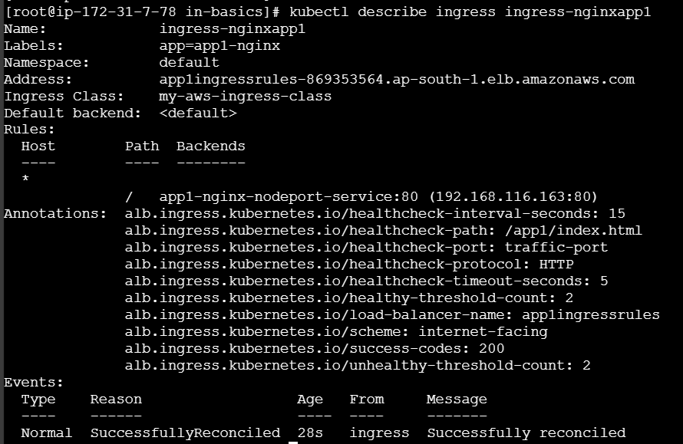
Verify the below commands.
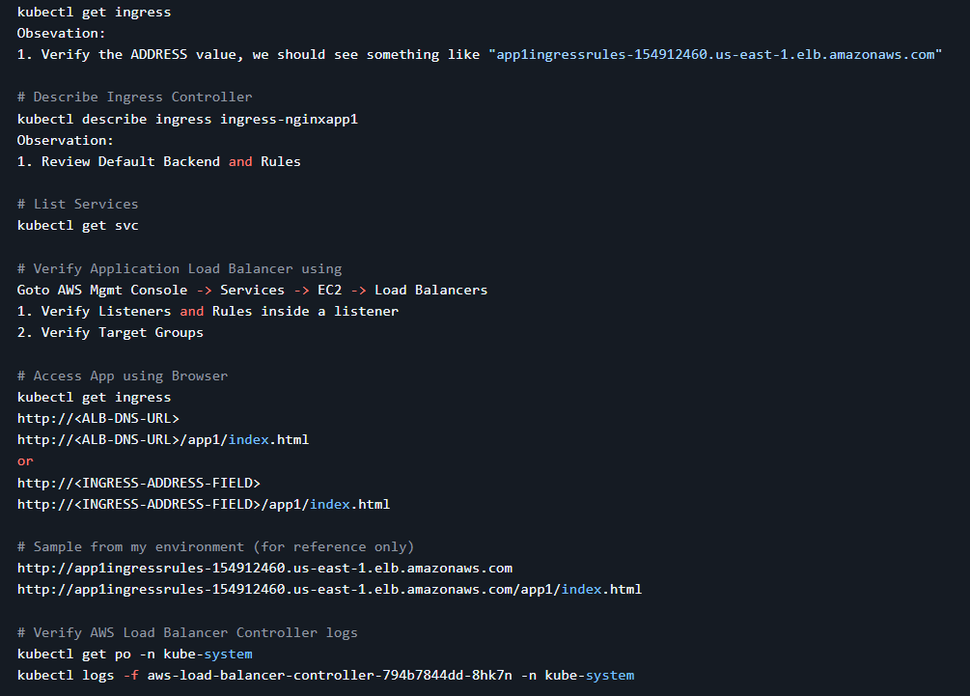
Note:- verify the LB, listener rules, TG everything in the LB level.
Finally clean it up.

